**TOPS TECHNOLOGY**

**HARDIK SHA**

**MODULE - 1**

**Q.1 What is SDLC?**

SDLC is based upon the Software Development Life Cycle. A process of planning and managing the whole structure of the project. There are different phases for developing the structure.

**Q.2 What is software testing?**

It is a one kind of checking process in the running project and after the complete developing job where testing identifies the bugs and queries and then after the solving it can meet up to the customer and project end user requirements.

**Q.3 What is agile methodology?**

Agile SDLC model is a combination of iterative and incremental process model. Where models focus on process adaptability and customer satisfaction by rapid delivery of working software products.

**Q.4 What is SRS?**

**Software Requirement Specification (SRS) Format** as the name suggests, is a complete specification and description of requirements of the software that need to be fulfilled for the successful development of the software system. These requirements can be functional as well as non-functional depending upon the type of requirement. The SRS is necessary to fully understand the needs of customers.

**Q.5 What is oops?**

Object Oriented Programming (OOP) is a programming language model organized around objects rather than “actions” and data rather than logic. OOP is a way to write the programming language in the proper manner.

**Q.6 Write the basic concept of oops**

* Object
* Class
* Encapsulation
* Inheritance
* Polymorphism
* Abstraction

**Q.7 What is an object?**

Object is an instance of a class that executes the class. Once the object is created, it takes up spaces like other variables in memory.

**Q.8 What is class?**

Class is a collection of objects and it doesn’t take any space in memory, class is also called a blueprint/logical entity.

**Q.9 What is encapsulation?**

Encapsulation is a way to restrict the direct access to some components of an object, so users cannot access state values for all of the variables of a particular object.

**Q.10 What is inheritance?**

Inheritance is the concept in OOPs in which one class inherits the attributes and methods of another class. The class whose properties and methods are inherited is known as the Parent class.

**Q.11 What is polymorphism?**

Polymorphism is one of the [core concepts of object-oriented programming (OOP)](https://stackify.com/oops-concepts-in-java/) that describes situations in which something occurs in several different forms. polymorphism describes the concept that you can access objects of different types through the same interface. Each type can provide its own independent implementation of this interface.

**Q.12 Draw Use Case on online book shopping**

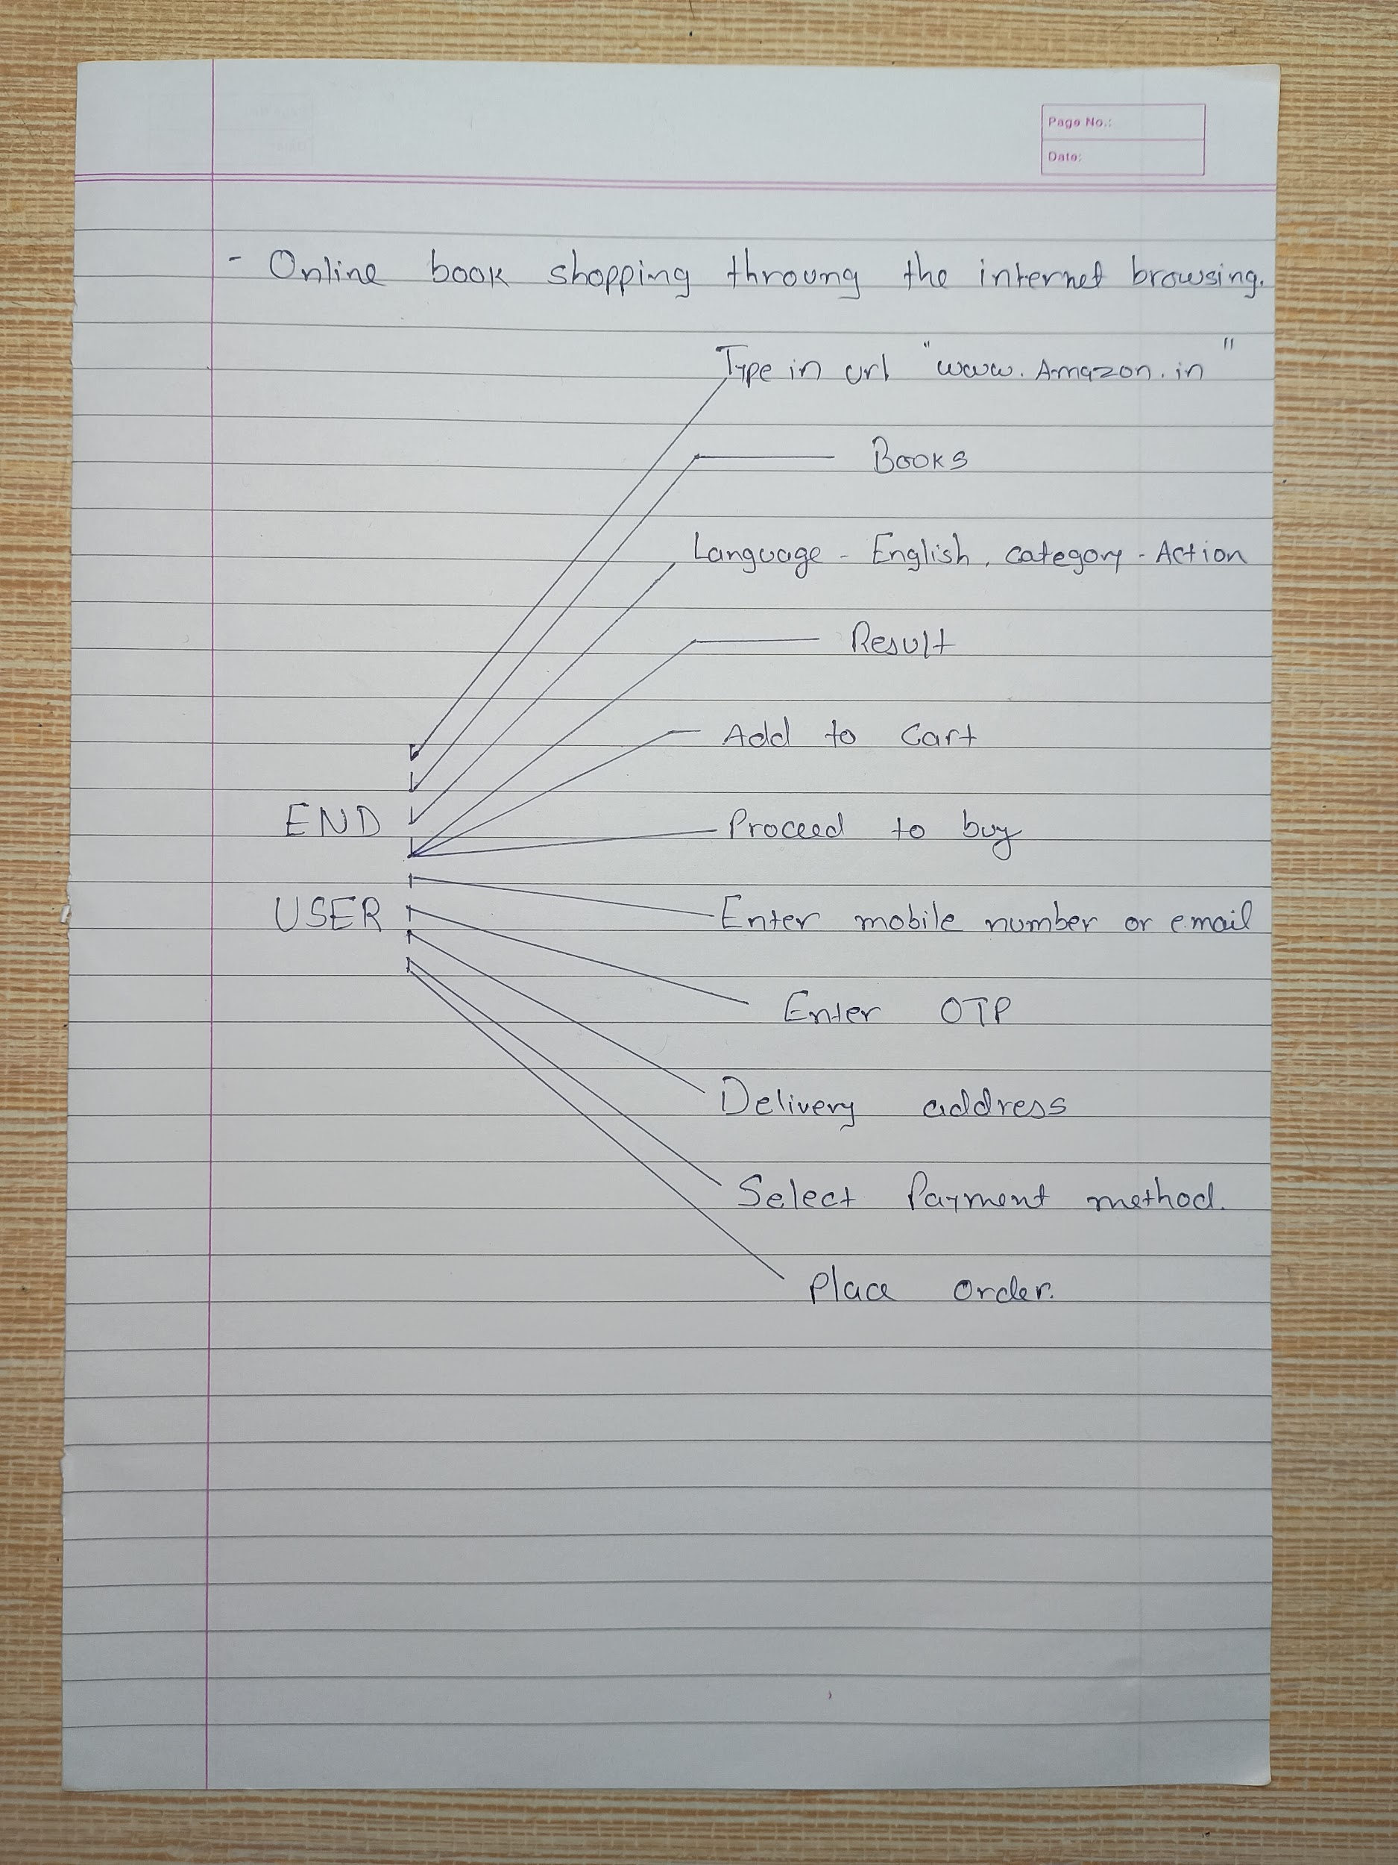

**Q.13 Draw use case on online bill payment system (Paytm)**

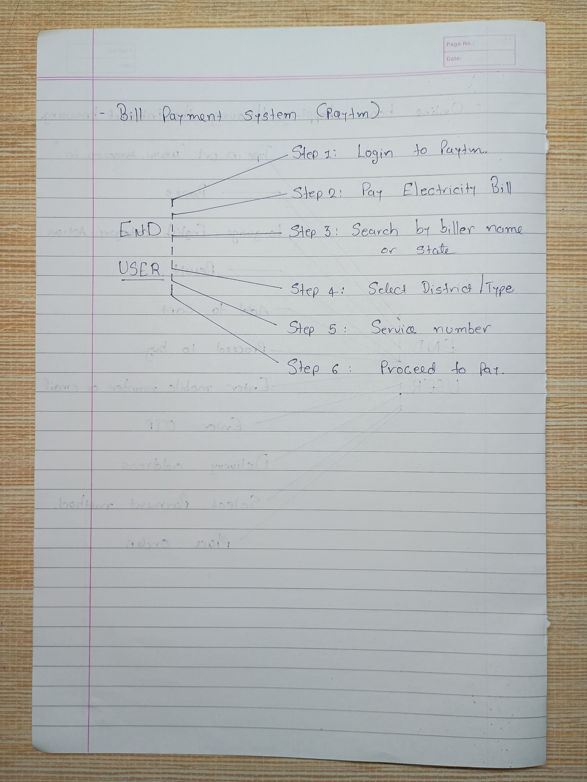

**Q.14 write SDLC phase with basic introduction**

There are six basic phases in the SDLC design module.

1. **Planning/ Requirement collection/ Gathering**

Requirements gathering is the process of identifying your project's exact requirements from start to finish. The key ingredients of the requirements gathering process are three overlapping subprocesses: requirements elicitation, requirements documentation, and requirements understanding.

1. **Defining/ Analysis**

The purpose of an analysis/ Defining is to interpret or find meanings or patterns in an informational way. This phase is when you evaluate the feasibility of creating the product, revenue potential, the cost of production, the needs of the end-users, etc.

1. **Design**

The design phase is a critical step in developing the conceptual blueprint of a software project. This phase involves collection of requirements and analysis into a structured design document.

1. **Coding/ Implementation**

The developer creates the actual product, and the product is installed and ready for coding. After the design product was built, the coding can begin. The coding process creates the operational or functional ability of the software product.

1. **Testing**

Once the developers build the software, then it is deployed in the testing environment. Then the testing team tests the functionality of the entire system. In this fifth phase of SDLC, the testing is done to ensure that the entire application works according to the customer requirements.

1. **Deploy/ Maintenance**

The maintenance phase happens after the project team deploys the software and it's fully operational in the customer environment. During the maintenance phase, the customer monitors the software functionality to ensure his requirements.

**Q.15 Explain phases of the waterfall model**

In the waterfall model, each phase depends on the deliverables of the previous one. After one stage is completed, it is not possible to go back to the previous stage. The phases of the waterfall model are requirement gathering, analysis and design, implementation, verification, deployment, and maintenance.

* **Requirements:** This is the first of the waterfall model phases, where the client has to provide the requirements for the software system.

* **Analysis and design:** After gathering all the requirements, it's time to move on to the design stage. Here, designers develop solutions that meet the requirements.
* **Implementation:** Once the design is finalized and approved, it's time to implement it. Design hands off their specifications to developers to build.
* **Verification:** After the developers code the design, it’s time for quality assurance. It’s important to test for all use cases to ensure a good user experience.
* **Deployment:** Once the software has been tested and approved, it is deployed to the production environment.
* **Maintenance:** The final phase of the Waterfall Model is maintenance, which involves fixing any issues that arise after the software has been deployed and ensuring that it continues to meet the requirements over time.

**Q.16 Write phase of spiral model**

The Spiral Model is a risk-driven model, meaning that the focus is on managing risk through multiple iterations of the software development process. It consists of the following phases:

1. **Planning:** The first phase of the Spiral Model is the planning phase, where the scope of the project is determined and a plan is created for the next iteration of the spiral.
2. **Risk Analysis:** In the risk analysis phase, the risks associated with the project are identified and evaluated.
3. **Engineering:** In the engineering phase, the software is developed based on the requirements gathered in the previous iteration.
4. **Evaluation:** In the evaluation phase, the software is evaluated to determine if it meets the customer’s requirements and if it is of high quality.
5. **Planning:** The next iteration of the spiral begins with a new planning phase, based on the results of the evaluation.

**Q.17 Write agile manifesto principles**

The agile manifesto has four principles as follows:

1. **Individual interactions**
2. **Working software**
3. **Customer collaboration**
4. **Respond to change**

**Q.18 Explain the working methodology of the agile model and also write pros and cons**

The Agile methodology is a project management approach that involves breaking the project into phases like Requirements, Planning, Analysis, Design, Coding, Testing, deployment and maintenance. Teams follow a cycle of planning, executing, and evaluating. The agile methodology is an update version of iterative and incremental modules.

**Pros:**

* **Flexibility**
* **Result comes rapidly**
* **Suitable for fixed and changing requirements**
* **Delivers early partial working**
* **Documentation easily employed with minimal rules**
* **Immediate Feedback**
* **Less Defective Products**

**Cons:**

* **Lack of Documentation**
* **Scope Creep**
* **Development team need to be available**
* **Lack of Predictability**

**Q.19 Draw use case on Online shopping products using COD.**

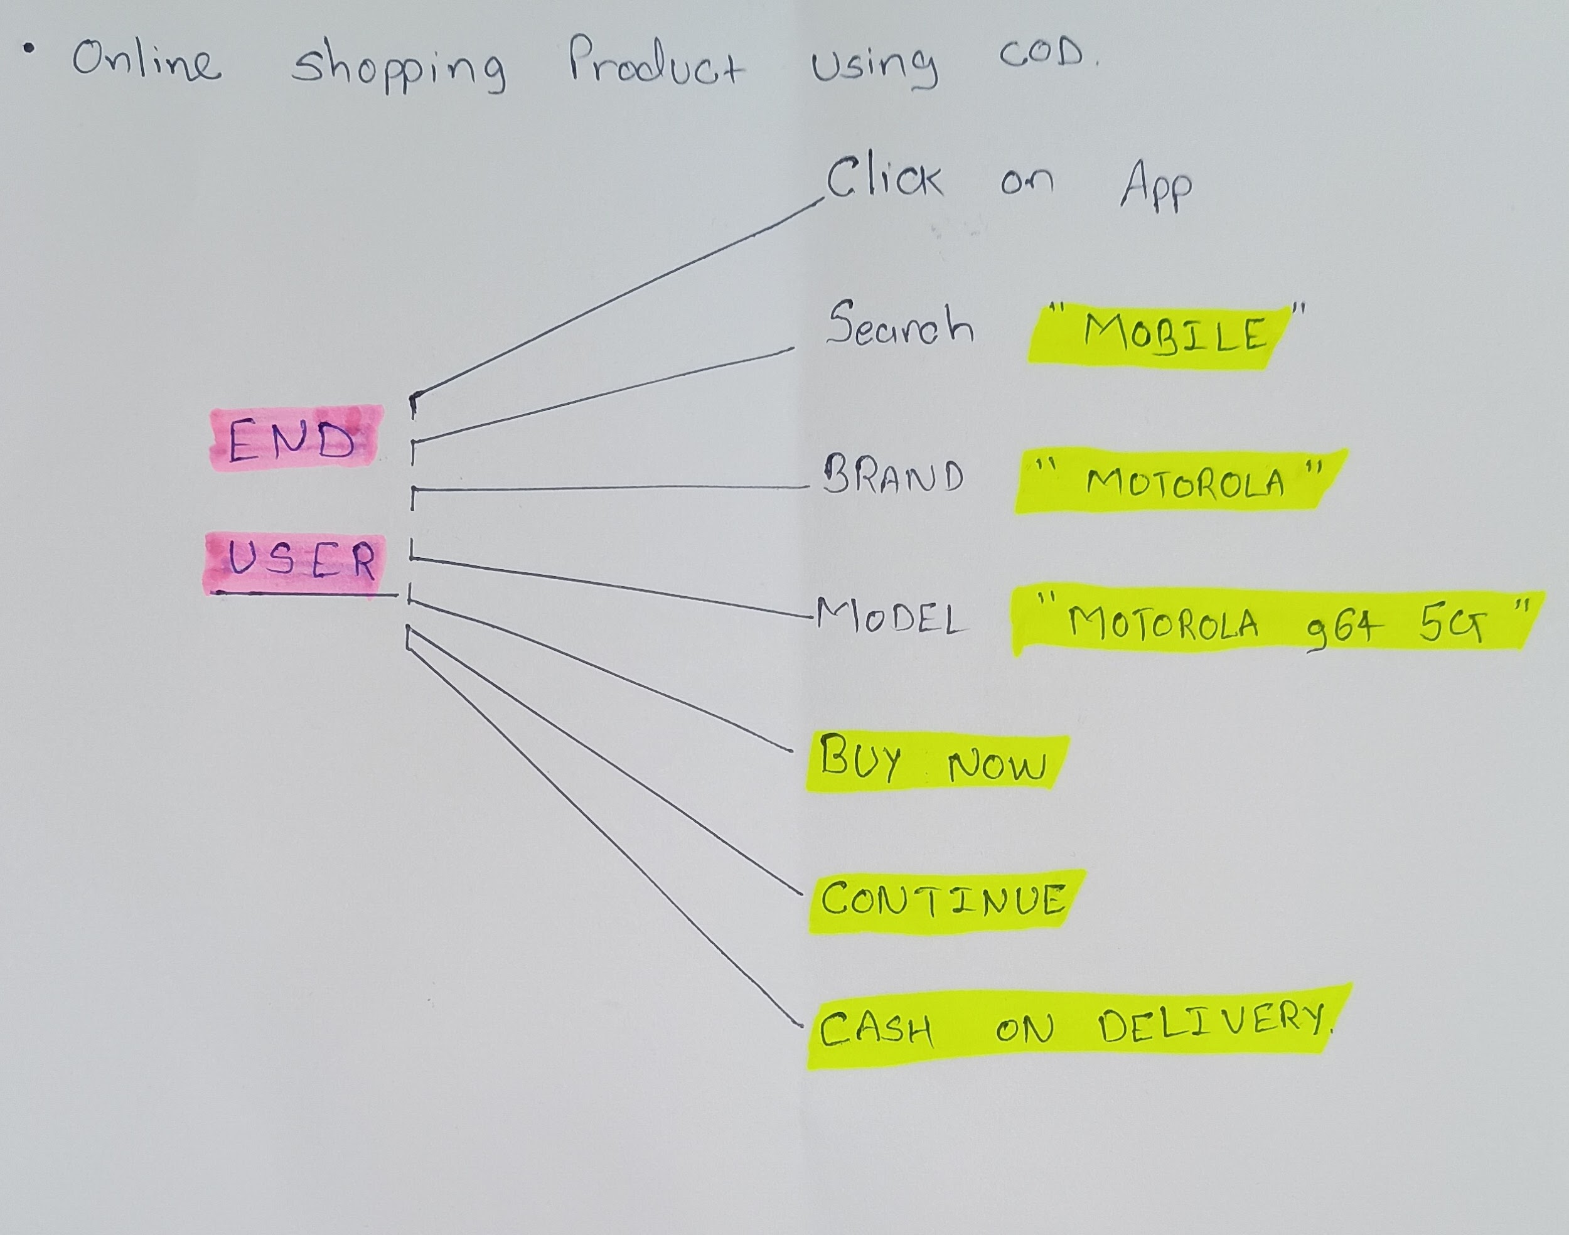

**Q.20 Draw use cases on Online shopping products using payment gateway.**

